**Lab 15: Android ViewPager**

# **Introduction**

A layout manager called ViewPager enables users to navigate across data pages by swiping left and right. The majority of the time, it appears in apps like Snapchat and YouTube where the user swipes right to left to change screens. Activities are replaced with fragments when using a ViewPager.

**Let’s get Started**

* The main layout in an XML layout is normally where the ViewPager widget is added.
* Extending the FragmentPagerAdapter or FragmentStatePagerAdapter class to create an adapter.
* The Viewpager's pages are filled out by an adaptor.
* FragmentPagerAdapter and FragmentStatePagerAdapter extend the base class PagerAdapter.

**Step 1: Create a New Project in Android Studio as shown below**

**Step 2: Select Empty Activity as shown below**

**Step 3: Provide a Project Name as shown below**

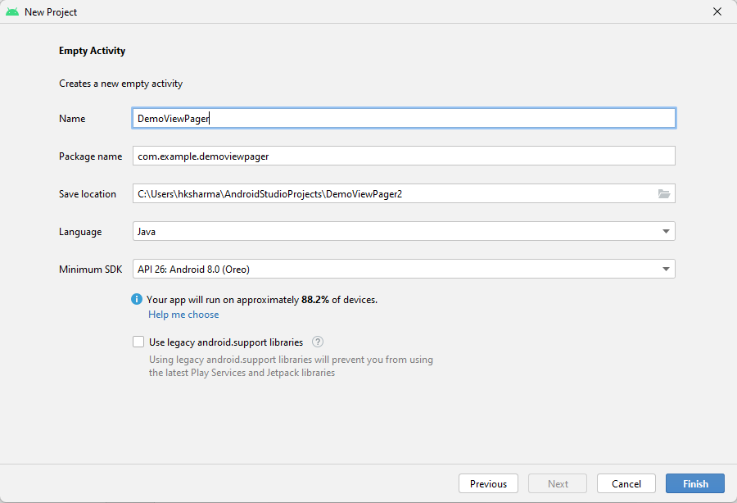

**Step 4: Update MainActivity.java as per the code given below**

**package** com.example.demoviewpager;  
**import** android.support.v4.view.ViewPager;  
**import** android.support.v7.app.AppCompatActivity;  
**import** android.os.Bundle;  
**import** android.view.Menu;  
**import** android.view.MenuItem;  
**import** androidx.appcompat.app.AppCompatActivity;  
**import** androidx.viewpager.widget.ViewPager;  
  
**public class** MainActivity **extends** AppCompatActivity {  
  
 @Override  
 **protected void** onCreate(Bundle savedInstanceState) {  
 **super**.onCreate(savedInstanceState);  
 setContentView(R.layout.***activity_main***);  
  
 ViewPager viewPager = (ViewPager) findViewById(R.id.viewpager);  
 viewPager.setAdapter(**new** CustomPagerAdapter(**this**));  
 }  
}

**Step 5: Update activity_main.xml for Vertical Orientation as per the code given below**

<RelativeLayout xmlns:android="https://schemas.android.com/apk/res/android"

xmlns:tools="https://schemas.android.com/tools"

android:layout_width="match_parent"

android:layout_height="match_parent"

tools:context=".MainActivity">

<android.support.v4.view.ViewPager

android:id="@+id/viewpager"

android:layout_width="match_parent"

android:layout_height="match_parent"/>

</RelativeLayout>

**Step 6: Check Output on Android Emulator and it should look like as given below**

**Voila!!** We have successfully completed this lab.